**GIT HANDSON**

**Exercise – 3**

**Git Branching and Merging**

Branching and merging are fundamental Git features that allow developers to work on different things in parallel without interfering with each other.

* Branching = Create a separate copy of the project to develop features, fix bugs, or experiment without affecting the main branch (main/master).
* You work on the branch independently. After creating a branch, you can make commits to it without affecting the master branch. This allows you to work on a new feature over several days, while other developers can continue working on the main codebase without being disrupted by your unfinished work.
* Merging = Combine your branch changes back into the main branch after testing, making them part of the main codebase.

Creating a Branch in GitLab

Creating a branch in GitLab is how you start a new line of work within a GitLab-hosted repository.

* In GitLab, you can create a branch from the repository page by typing a new branch name; it copies the current branch.
* Create branches for specific tasks, naming them descriptively (e.g., fix-login-bug).
* Branches made in GitLab are visible to everyone for collaboration.

Creating a Merge Request in GitLab

A Merge Request (MR) in GitLab is a formal way to ask for your branch's changes to be merged into another branch (like master). This is also known as a "Pull Request" in other platforms like GitHub.

* Merge Request (MR) starts a review process where reviewers can comment and suggest changes.
* Shows a summary of commits and a detailed diff of changes.
* Allows automated tests and safe merging after approval.

**Step1**: Create new Branch “GitNewBranch” and switch to it

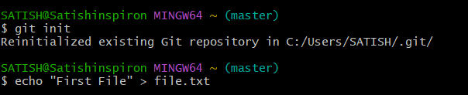

**Step2:** Create a new file with some text inside new Branch and commit it

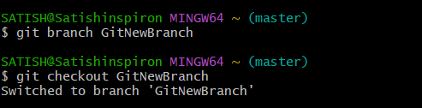

**Step3:** Noe check status of git and its clear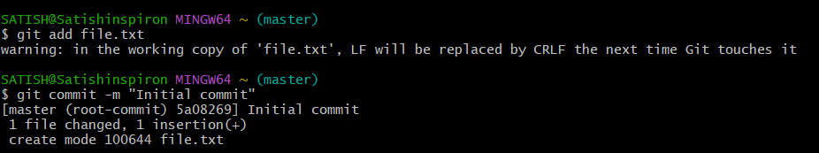

**Step4**: Before merging, you must be on the branch you want to merge *into* and List out all the differences between trunk and branch

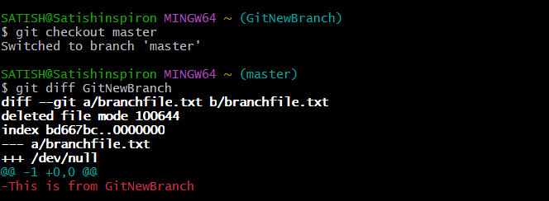

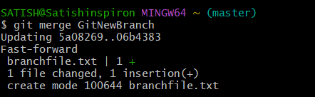**Step5**: Now merge them

**Step6**: Use the specified git log command to view the commit history in a compact, graphical format

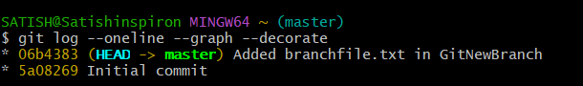

Step7: Delete the branch after merging and observe the git status.